Assignment 1 – Create the architecture diagram of automation framework

Page Object Model -

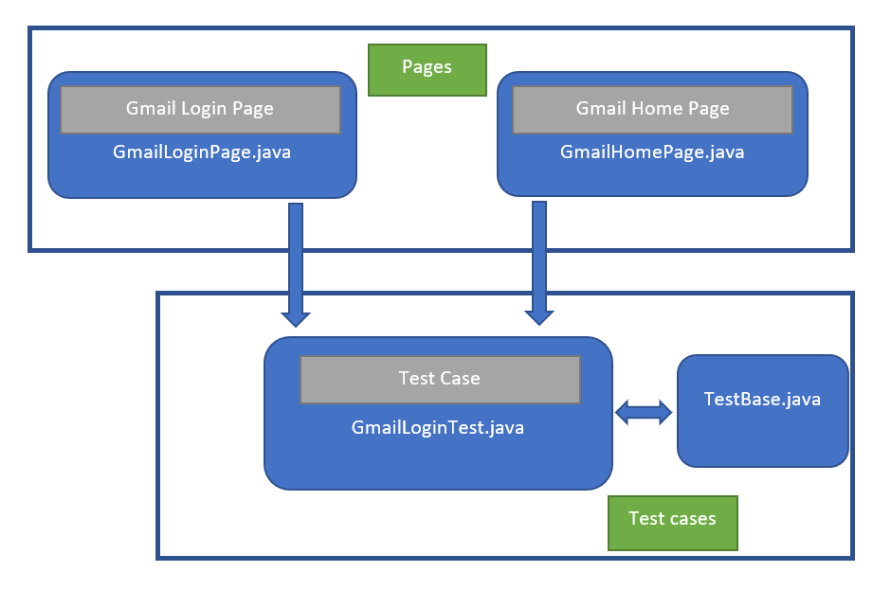

base(Base Classes)

pages(page Classes)

tests(test Classes)

Configuration file

Screenshots

Test reports

Page Object Model:
Page Object Model (POM) is a design pattern, popularly used in test automation that creates Object Repository for web UI elements. The advantage of the model is that it reduces code duplication and improves test maintenance.

1) Base classs : - Base Page Class is the one from which classes of all other pages inherit. We will therefore create it first, populate it with methods for the most common actions that are expected to be performed on any page in the application. It can have helper methods used for logging purpose, taking screenshots, handling exceptions, etc.

2) Page Classes – One class for each web page in the application. Find the webelements of web page and declare it. There will be methods to return these webelements. We can create new class for each web page.

3) Test Classes - The test case file should contain test logic only. We have to keep ‘test’ as prefix or suffix for testcase file name as well as for methods name. Create the object of page class to access defined web elements.

4) Configureation – We can create config file and put all configuration in it. Like drivers (chromedriver, geckodriver) , Base URL , Username, Password. Also, browser selection for test execution can also be defined using addoption parser.

Advantages:

1) Makes our code cleaner and easy to understand.
2) Tests are more readable, flexible and maintainable
3) Re-usable code that reduces redundancy of code
4) Shorten the learning curve for testers and help QA teams meet timelines.

